ASR Open TO Detail Report :

**From:** Zhi Ai, Huang   
**Sent:** Tuesday, September 02, 2014 1:40 PM  
**To:** Chan, Pei-Fong; 'Jack Fong'  
**Cc:** 'Jack Fong'  
**Subject:** Create Open order details report in WMS

Hi PeiFong,

Please assist to create a report as “Open Order Details Report” in WMS which able retrieve open orders after SAP data uploaded into WMS.

The report criteria to be retrievable by Wavekey & Shipment no. and from date to date.

Please advise when can be done then I will raise ASR to request.

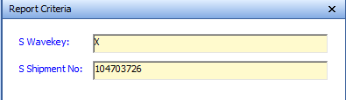

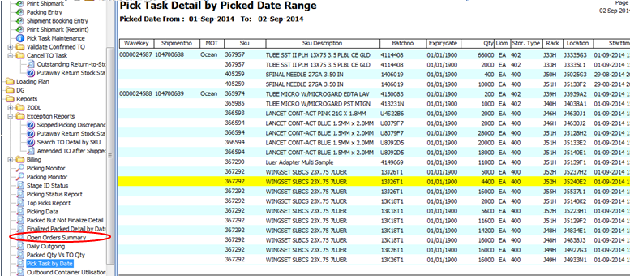

*Best Regards,*

***HUANG, ZhiAi (Mr)***

*Contract Logistics/SCM, Operations*

*Schenker Singapore (Pte) Ltd*

*5 Tuas View Lane, Singapore 637291*

*DID: +65 6795 2572  Mobile: +65 8383 8397*

WMS Changes:

New repor:

**From:** Chan, Pei-Fong   
**Sent:** Monday, September 08, 2014 4:23 PM  
**To:** Zhi Ai, Huang  
**Cc:** Jack, Fong  
**Subject:** RE: Create Open order details report in WMS

Hi Zhi AI,

The requested new report is ready in production, please get latest updated WMS application.

Please validate.

Under [REPORT] -> Open Orders – Detail

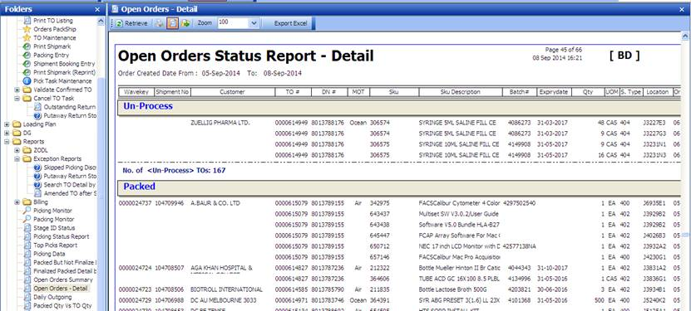

Tested by Zhi Ai:

